./

GENESIS

**Learning Report on**

**MODEL BASED SYSTEM ENGINEERING**

**(MBSE)**

(MBSE)



|  |  |  |  |  |  |
| --- | --- | --- | --- | --- | --- |
| **Ver. Rel. No.** | **Release Date** | **Prepared. By** | **Reviewed By** | **To be Approved** | **Remarks/Revision Details** |
|  | 17-2-2021 | Sneha Anand |  |  |  |
|  |  |  |  |  |  |
|  |  |  |  |  |  |
|  |  |  |  |  |  |
|  |  |  |  |  |  |

**Details**

TABLE OF CONTENTS

Contents 3

ACTIVITY 1 : AITUOMATION SCRIPT IN MATLAB 5

___________________**1.1 AUTOMATION 5**

**___________________****1.2 AUTOMATION SCRIPT USING MATLAB TO FETCH DATA FROM A WEBSITE 5**

ACTIVITY 2 : ALGORITHM DEVELOPMENT USING SENSOR DATA FROM ANDROSENSOR _____________APPLICATION 6

ACTIVITY 3 : model based design of a differential equation using simulink 7

ACTIVITY 4 : model based design of difference equation using simulink 8

ACTIVITY 5 : model based design AND BODY CONTROL MODULE

__________________**5.1 MODULE BASED DESIGN**

**__________________****5.2 BODY CONTROL MODULE**

**ACTIVITY 6 : ONRAMP CERTIFICATIONS ………………………………………………………………………………**

**LIST OF FIGURES**

**Figure 1: CODE SNIPPET OF AUTOMATION SCRIPT** **5**

**Figure 2: PLOT INDICATING THE USE OF PHONE/ DEVICE USING GYROSCOPE READING FROM ______ANDRO-SENSOR DATA** **6**

**Figure 3: SIMULINK MODEL FOR DIFFERNTAIL EQUATION** **7**

**Figure 4: SIMULINK MODEL FOR DIFFERENCE EQUATION** **8**

**Figure 5:** [**Body Control Module (BCM) in Automotive**](https://www.google.com/url?sa=i&url=https%3A%2F%2Fwww.intellias.com%2Fbody-control-module-bcm-in-automotive%2F&psig=AOvVaw21Ubfks1YCJBAQ1RDxQsu5&ust=1613578037492000&source=images&cd=vfe&ved=0CA0QjhxqFwoTCPiRq-Pk7u4CFQAAAAAdAAAAABAD)  **10**

**FIGURE 6: THE INTERIOR LIGHT SYTEM 12**

**FIGURE 7: THE SUBSYSTEM FOR INTERIOR LIGHT 12**

**Figure 8: Internal structure of subsystem** **12**

**FIGURE 9: INTEGRATED BCM 13**

# ACTIVITY 1

**AUTOMATION SCRIPT IN MATLAB**

### 1.1 AUTOMATION

Automation is a broad term that can cover many areas of technology where human input is minimized. This can include everything from business-specific types such as: business process automation (BPA), IT automation, marketing automation and industrial automation. It also covers personal applications such as home automation.

Usually, automation is employed to minimize labour or to substitute humans in the most menial or repetitive tasks. For example, most manufacturing plants make use of some automated process in the form of robotic assembly lines. Human input is required only to define the processes and supervise them, while the assembling of the various components is left to the machines, which automatically convert raw materials into finished goods.

In the information technology domain, a software script can test a software product and produce a report.

### 1.2 AUTOMATION SCRIPT USING MATLAB TO FETCH DATA FROM A WEBSITE

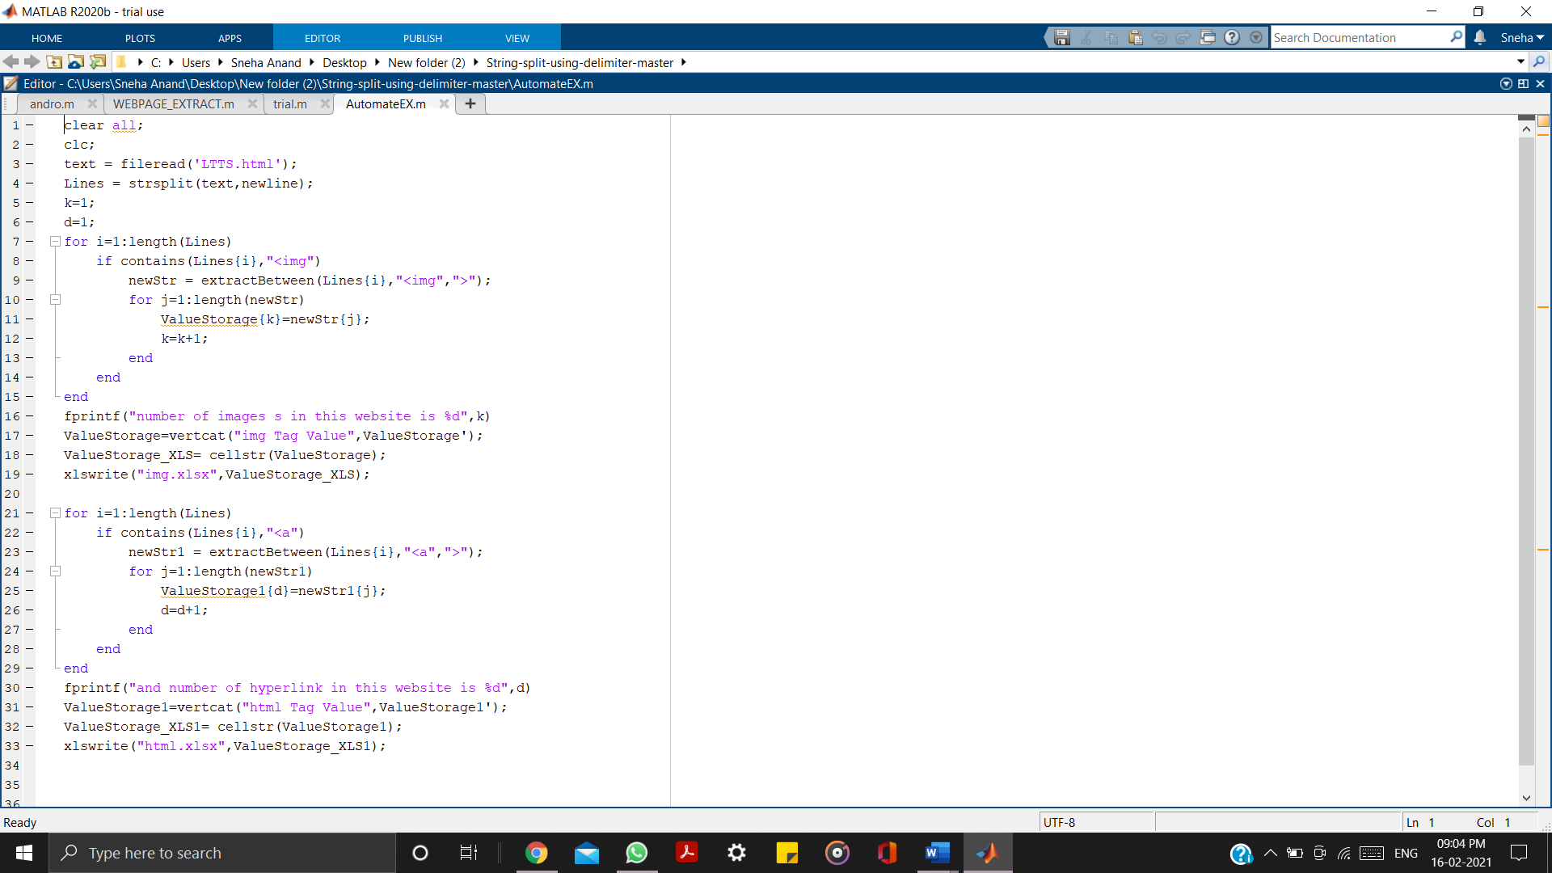

[**Link to MATLAB Code:**](https://github.com/99003525/MBSE/blob/main/MATLAB/AutomateEX.m)

**Links to Excel file**s:

1. [Webpage used](https://github.com/99003525/MBSE/blob/main/MATLAB/html.xlsx)
2. [HTML tag data](https://github.com/99003525/MBSE/blob/main/MATLAB/html.xlsx)
3. [Images data](https://github.com/99003525/MBSE/blob/main/MATLAB/img.xlsx)

Figure 1: Code snippet of automation script

# ACTIVITY 2

**ALGORITHM DEVELOPMENT USING SENSOR DATA FROM ANDROSENSOR APPLICATION**

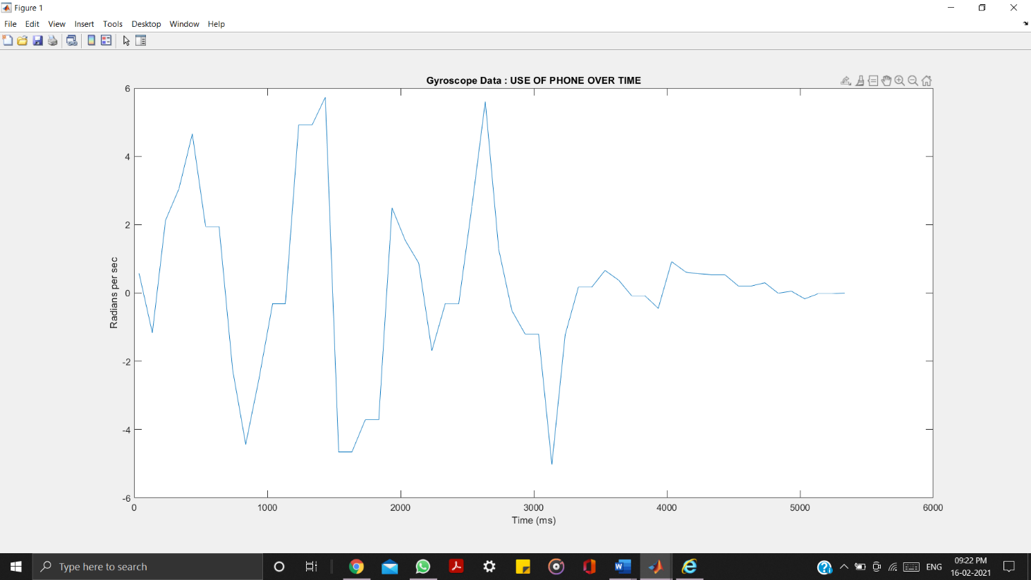

Figure 2: Plot indicating the use of phone / device using gyroscope reading from Andro-sensor Data

[**Link to MATLAB Code**](https://github.com/99003525/MBSE/blob/main/MATLAB/Algorithm_matlab.m)

[**Link to Excel file**](https://github.com/99003525/MBSE/blob/main/MATLAB/sample.csv)

# ACTIVITY 3

**MODEL BASED DESIGN OF A DIFFERENTIAL EQUATION USING SIMULINK**

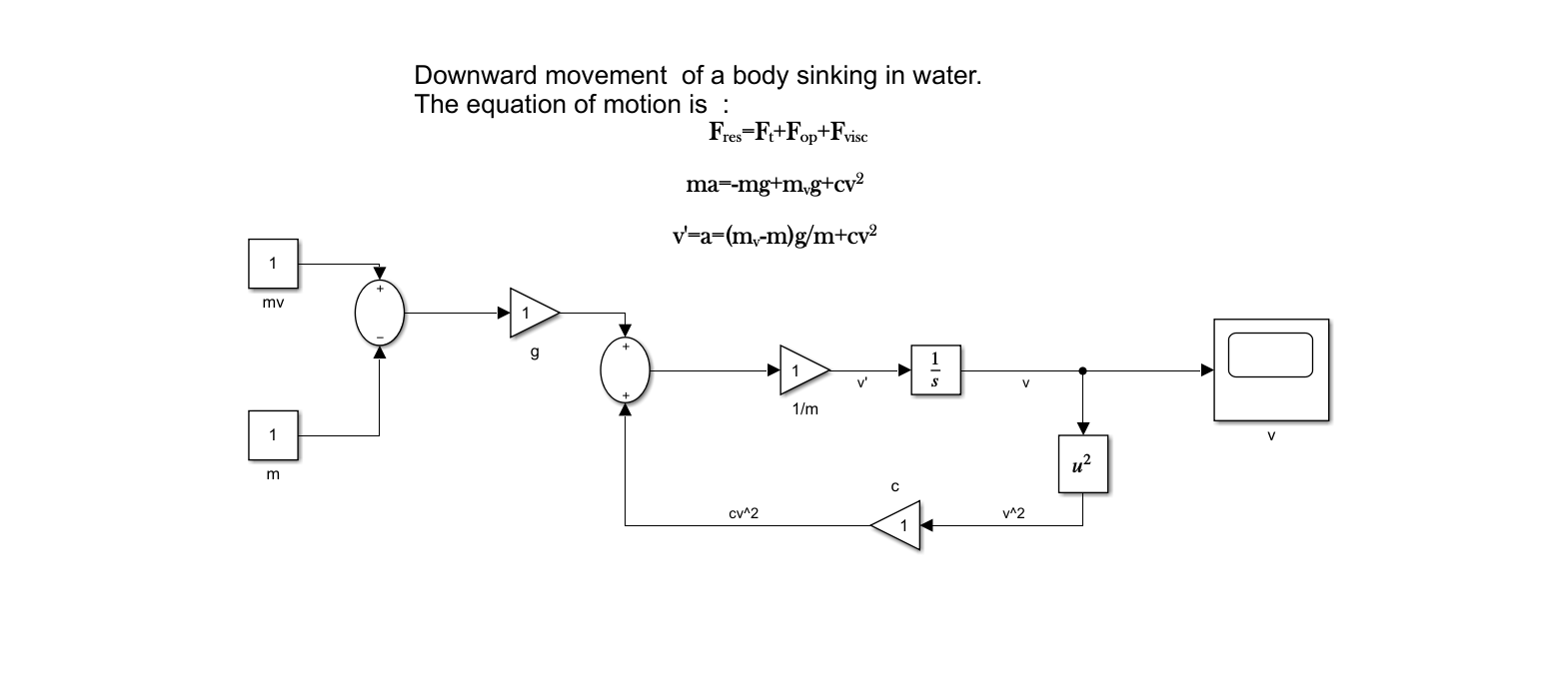

# Figure 3: Simulink model for a differential equation ( [link to the file](https://github.com/99003525/MBSE/blob/main/SIMULINK/Differntial_equation_model.slx) )

# ACTIVITY 4

**MODEL BASED DESIGN OF A DIFFERENCE EQUATION USING SIMULINK**

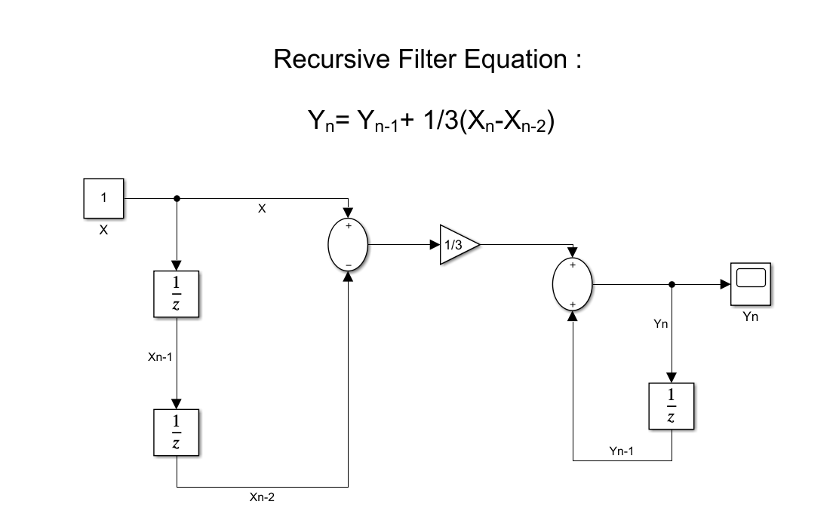

# Figure 4: Simulink model for a difference equation ( [link to the file](https://github.com/99003525/MBSE/blob/main/SIMULINK/Difference_equation_model.slx) )

**ACTIVITY 5**

**MODEL-BASED DESIGN AND BODY CONTROL MODULE**

**5.1** [**MODEL-BASED DESIGN (MBD)**](https://en.wikipedia.org/wiki/Model-based_design)

MBD is a mathematical and visual method of addressing problems associated with designing complex control, signal processing and communication systems. It is used in many motion control, industrial equipment, aerospace, and automotive applications Model-based design is one solution that substitutes the traditional approach to automotive software development.

In model-based design of control systems, development is manifested in these four steps:

1. Modelling a plant,
2. Analysing and synthesizing a controller for the plant,
3. Simulating the plant and controller,
4. Integrating all these phases by deploying the controller.

The model-based design is significantly different from traditional design methodology. Rather than using complex structures and extensive software code, designers can use Model-based design to define plant models with advanced functional characteristics using continuous-time and discrete-time building blocks. These built models used with simulation tools can lead to rapid prototyping, software testing, and verification.

Not only is the testing and verification process enhanced, but also, in some cases, hardware-in-the-loop simulation can be used with the new design paradigm to perform testing of dynamic effects on the system more quickly and much more efficiently than with traditional design methodology.

Model-based design allows faster releases, enhanced design, and better reliability in automotive embedded systems. Tools for software modeling and simulation can improve automotive systems as long as they continue to demonstrate benefits and become more common in the industry.

**5.2 BODY CONTROL MODULE**

In automotive electronics, **body control module** or 'body computer' is a generic term for an electronic control unit responsible for monitoring and controlling various electronic accessories in a vehicle's body. Typically in a car the BCM controls the power windows, power mirrors, air conditioning, immobilizer system, central locking, etc. The BCM communicates with other on-board computers via the car's vehicle bus, and its main application is controlling load drivers – actuating relays that in turn perform actions in the vehicle such as locking the doors or dimming the interior lighting.

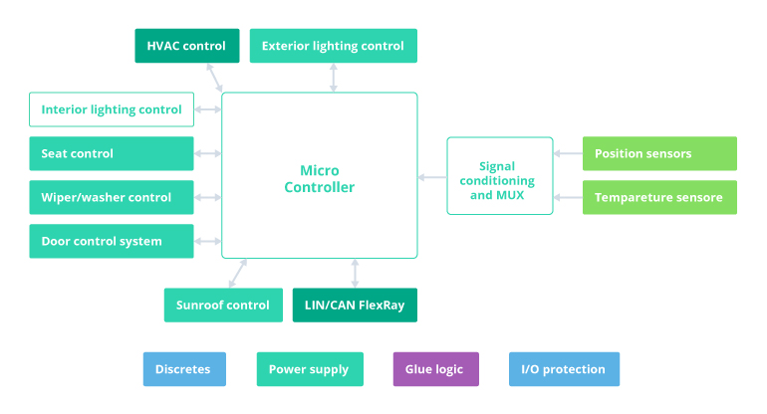

Figure 5: [Body Control Module (BCM) in Automotive](https://www.google.com/url?sa=i&url=https%3A%2F%2Fwww.intellias.com%2Fbody-control-module-bcm-in-automotive%2F&psig=AOvVaw21Ubfks1YCJBAQ1RDxQsu5&ust=1613578037492000&source=images&cd=vfe&ved=0CA0QjhxqFwoTCPiRq-Pk7u4CFQAAAAAdAAAAABAD)

A BCM can perform multiple control-related operations simultaneously. One of the major objectives of this module is to detect malfunctions in the work of electrical system components.

**5,3 MBD OF BCM : Internal Lighting**

This feature controls the brightness of the interior lights based on the extent up to which the door is being opened. As and when the door opens or closes the intensity of the lights within the automotive i.e. the dome lights and the entry lights, will vary accordingly with the highest intensity of light being emitted when the door is opened completely and the lowest intensity when then door is shut completely . This feature can be used even when the ignition is turned off.

**TEST PLAN:**

|  |  |  |  |
| --- | --- | --- | --- |
| **TEST_ID** | **DESCRIPTION** | **INPUT** | **OUTPUT** |
| 1 | If the door is opened completely the intensity of the interior light should be at its peak (highest) | Door open = 5 | Light intensity = 5 |
| 2 | If the door is closed completely the intensity of the interior light should be at its peak (lowest) | Door open = 0 | Light intensity = 0 |
| 3 | During the period between door being completely open and completely closed,  The intensity of the interior light should vary accordingly | Door open =1.5 | Light intensity = 1.5 |

Table 1: Test Plan

[**Link to Simulink Model**](https://github.com/99003525/MBSE/blob/main/SIMULINK/interior_light.slx)

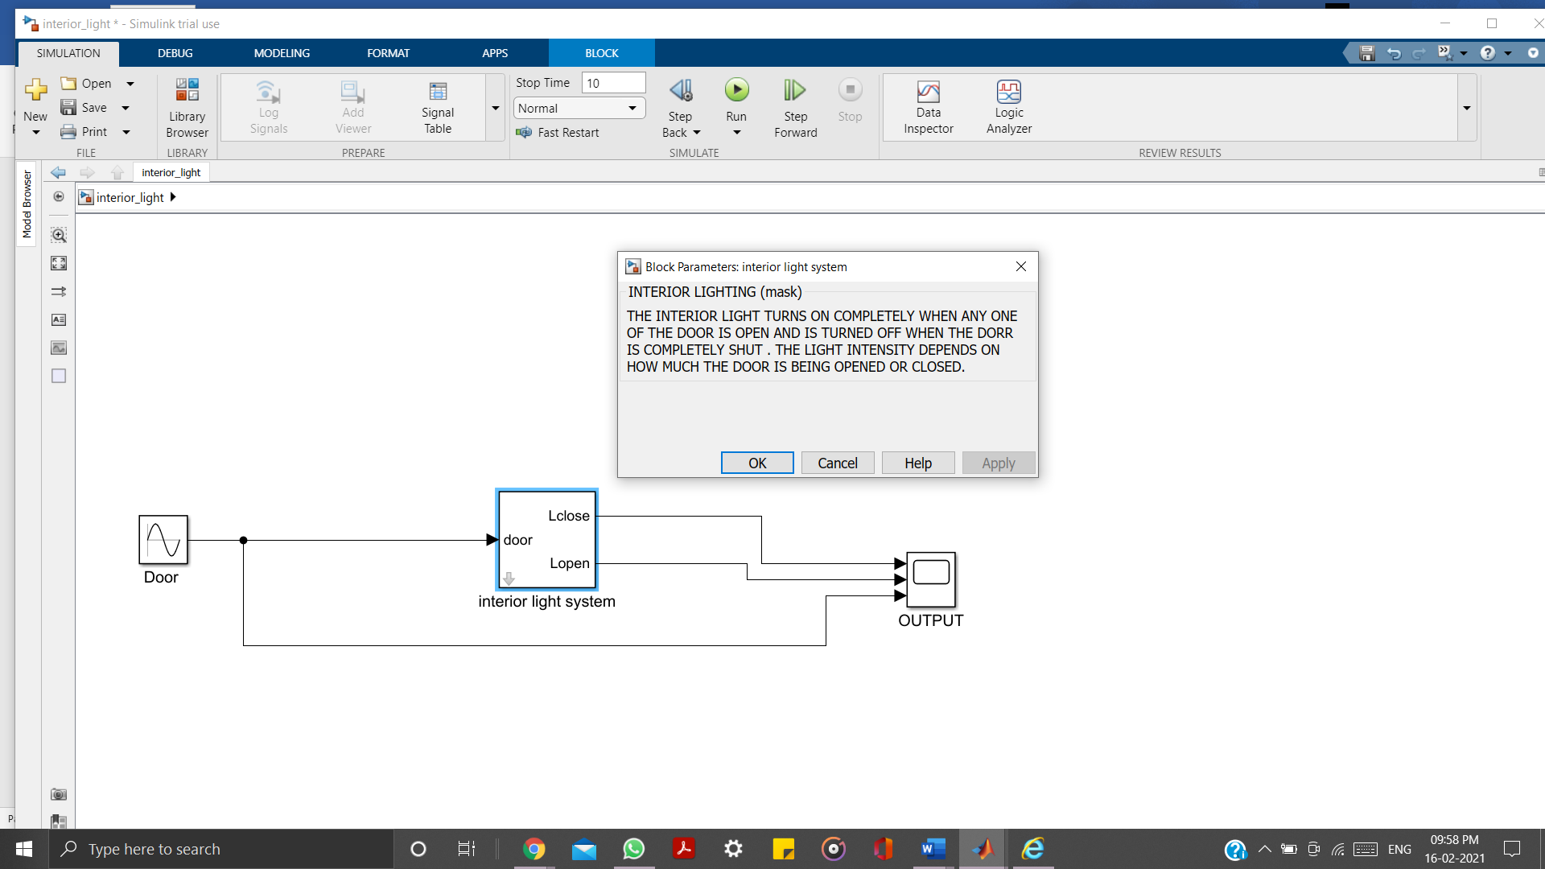

Figure 6: The interior light system

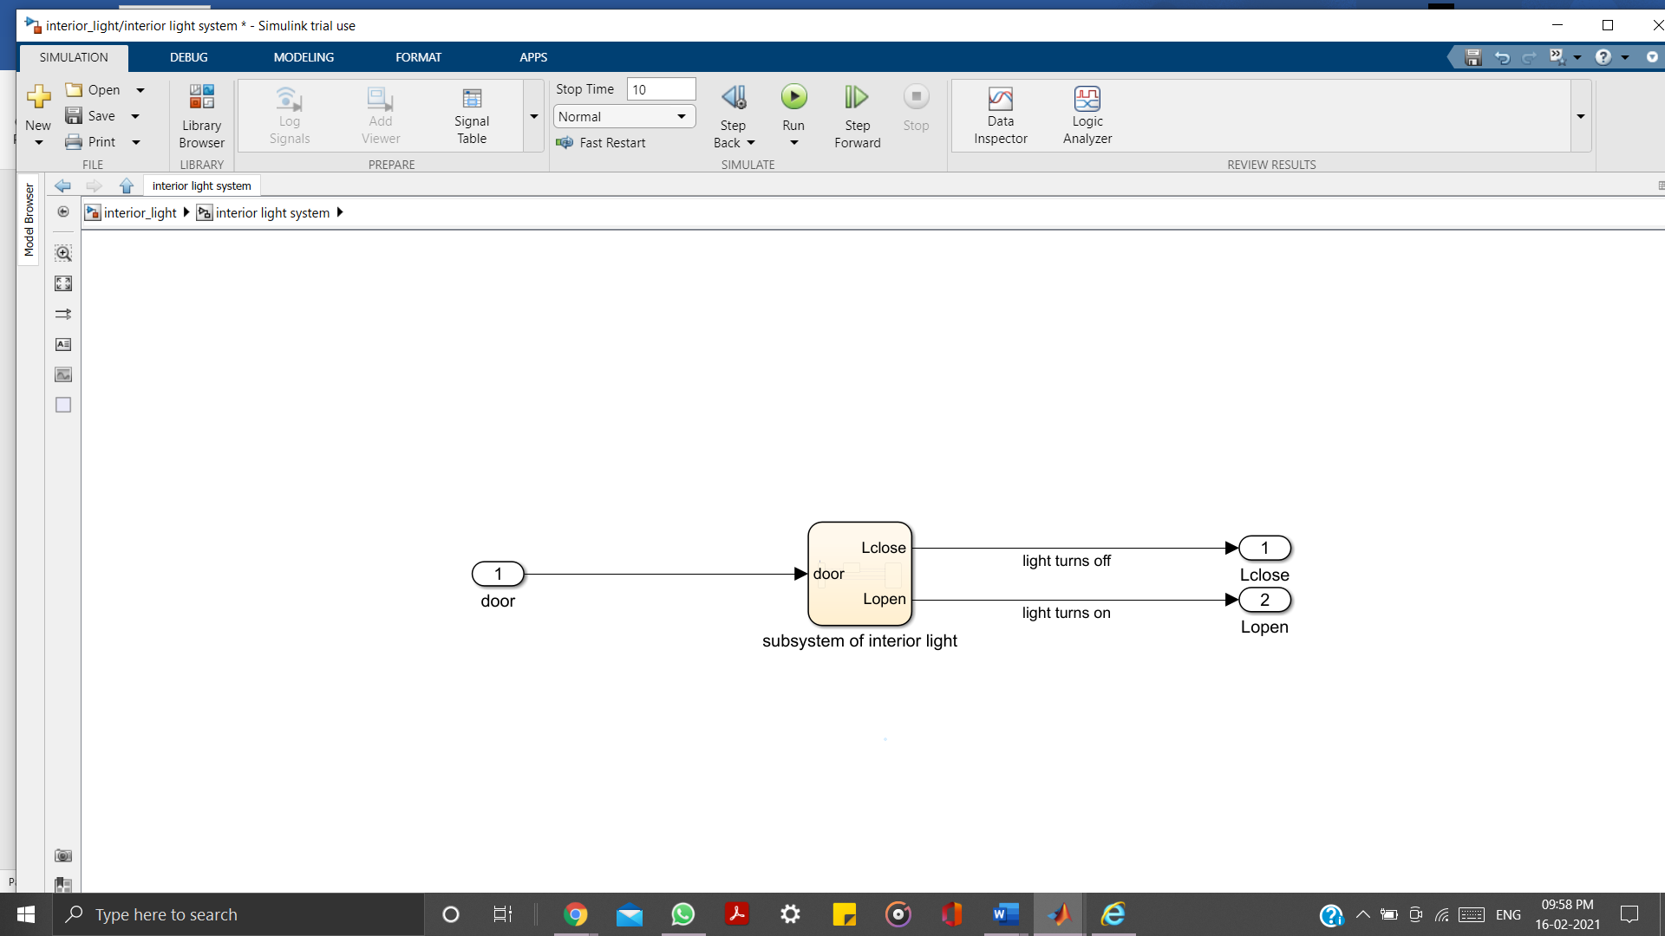

Figure 7 : The interior lighting subsystem

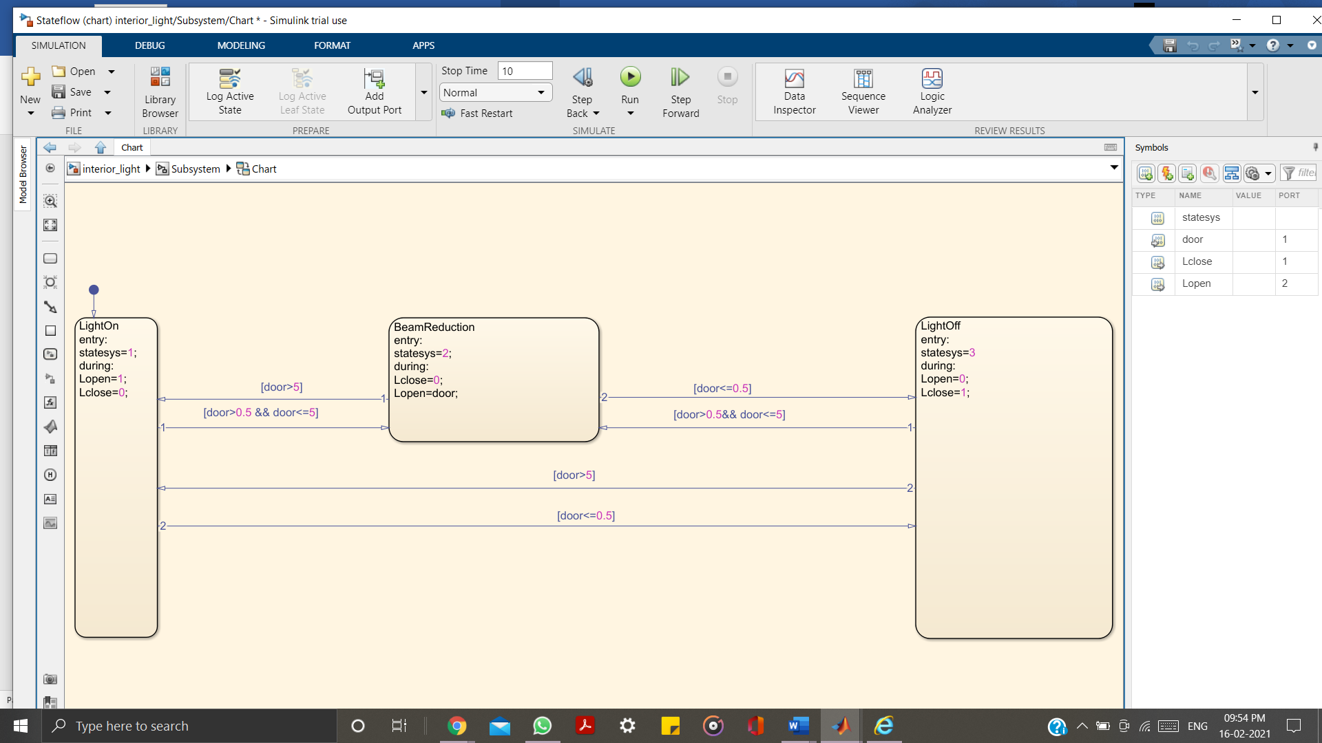

Figure 8 : Internal structure (stateflow) of the subsystem

**6. CERTIFICATES**

**MATLAB ONRAMP CERTIFICATE:**



**SIMULINK ONRAMP CERTIFICATE:**



**STATEFLOW ONRAMP CERTIFICATE:**

